

KIKOMEKO JOHN BAPTIST

Age: 21years

Nationality: Ugandan

Home Address: Wabigalo,Mityana

Email: kikomekojohnbaptist@gmail.com

Contact: +256 757097712

Date of Birth: 23rd December 2001

Place of Birth: Mityana

Place of residence: Kibiiri, Wakiiso

Gender: Male

Marriage status: single

**Profile**

Am an IT college student who is hard working, trustworthy and faithful.

I am a junior web designer and a college student who wants to become a Software Engineer in Future, I also like Programming.

**Education Background**

|  |  |  |
| --- | --- | --- |
| YEAR | INSTITUTION | AWARD |
| 2008-2016 | Fremma Primary School | Primary Leaving  Certificate |
| 2017-2020 | Central College Mityana | Uganda Certificate of Education |
| 2022-(2023)To date | Buganda Royal Institute of Bossiness And Technical Education | National Certificate of Information and Communication Technology |

**Work**

Junior Website Designer and developer and I have done few web projects as an individual and group.

**Skills**

|  |  |
| --- | --- |
| skill | Percentage of knowledge |
| Web design(HTML,CSS AND JAVASCRIPT) | 80% |
| Networking and computer Repair | 70% |
| Graphics and Photo editing | 60% |
| Programming | 50% |
| Documentation publishing | 100% |

Languages

Luganda: 100%

English : 85%

Hobbies and interests

|  |
| --- |
| Playing football |
| Cording |
| Video Gaming |
| Watching Movies and football |
| Traveling |

Declaration

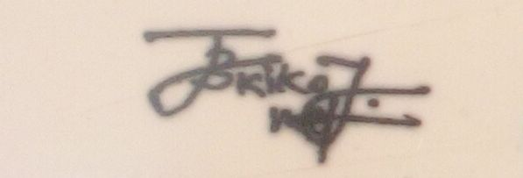I kikomeko John Baptist declare that the above given information is true to the best of my knowledge and understanding.

…………………………

signature